## Lab 2-01: Resource Hierarchy-Hands On

### Lab Prerequisites

* Familiarity with basic Google Cloud Computing concepts and terminology.
* A Google account with an active subscription.

### Service Introduction

Google Cloud resources are arranged hierarchically, with the organization node at the top of the hierarchy, projects as children, and other resources as offspring of projects.

IAM policies can be implemented at the following levels of the resource hierarchy:

* Organization: The company is represented by the organizational resource. IAM roles issued at this level are passed down to all resources within the company.
* Folders: Folders may contain projects, other folders, or a combination of both. Projects or other folders in that parent folder will inherit any roles provided at the highest folder level.
* Project: It implies a trust boundary within the organization. A default level of trust exists across services within the same project. App Engine instances, for example, can access Cloud Storage buckets within the same project. Resources inside that project inherit project-level IAM responsibilities.
* Resources: The policy defines a limit for the resource. The projects are only allowed to use the resource within the limit.

### Case Study Electronic Gadgets Company – NexaTech

Background

NexaTech is a company that sells a range of electronic gadgets and smartphones to consumers. It is a large multinational organization headquartered in Europe but has executive offices in Asia, North America, and Australia. These executive offices are paired with data centers and servers, which connect them to customers and other offices. Customers in Africa and South America have started complaining about downtime when connecting to customer service or accessing websites and applications. Furthermore, NexaTech had not been profitable in the last two financial years, losing much of it stock value.

NexaTech has been advised by professionals to migrate to cloud because it has no capital expenditure, and a large portion of the company’s profit is being invested in maintaining and operating its infrastructures. Considering this complaint, lack of revenue, and professional advice, NexaTech has decided to move its operations to the Cloud.

Business Challenge

Prior to moving to cloud, NexaTech and its employees were used to a hierarchal system in which different teams were set up for different purposes. And these teams were independent of other teams and had separate resources, but a common superior controlled them. Furthermore, the executives controlled the superior and so forth. Now, if a rule is applied at the executive level, it had effects to all its denominators. Therefore, every decision made by the executives affected all the development teams.

NexaTech is looking for a similar style of operations within the Cloud so their teams and employees do not have to adjust to a new environment.

NexaTech has collaborated with Google, and you, as a Cloud Architect, have been asked to come up with a solution to their situation.

### Proposed Solution

You have suggested that NexaTech takes full advantage of the resource hierarchy because its pyramid system is very similar to what the company and its employees are already used to.

Lab Diagram

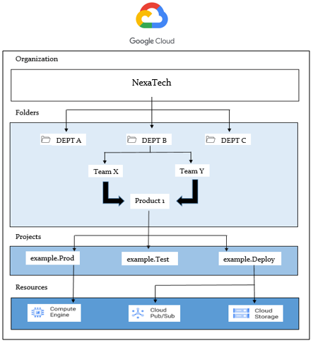

Figure 2-04: Lab diagram

Implementation Steps

1. Inspect the organization node.
2. Add resources to the organization node.
3. Recheck the organization node for resources.

Solution

|  |
| --- |
| Let’s have a look at the different nodes of the resource hierarchy described in the previous lecture in the GCP Console. We have four components in the resource hierarchy: Organization Node, Folder, Project, and Resource.   1. Log in to “GCP Console”. 2. First, have a look at the Organization node by clicking on the blue icon located in the top right corner.      1. The user email is the Organization node. 2. To find the projects and folders in an organization, click on the current project. It will drop down a list of all the projects.      1. Click “ALL”.      1. This is the Organization Name. 2. Inside this, there are organization node, folders, and projects.      1. If you click on the organization node, you will notice there is no dashboard because the organization does not contain any resource.      1. Go to the Navigation Panel. Select “IAM & Admin”. 2. Select “IAM”.      1. You can check the permission roles of project node here.      1. Go to “IAM & Admin”. Select “Manage resources”.      1. It will drop down a list of the projects, which were already created. 2. You can check whether each Project contains a Project ID and a user name. 3. Go to “CREATE PROJECT” and create a new project.      1. Provide a globally unique name, and it will automatically suggest the same project ID for the project. 2. You are also prompted for the location where you want to place your project. 3. Create the project.      1. Here, you have Project Name, Number, and ID. |